TC-VER-008
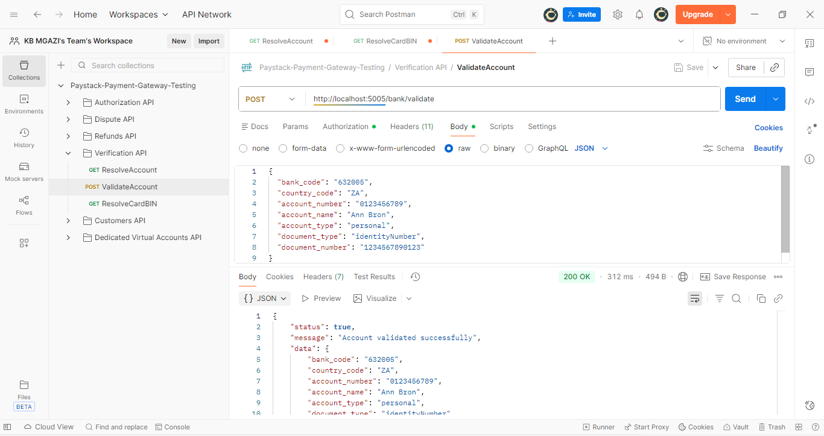
Response:
{
"status": true,
"message": "Account validated successfully",
"data": {
"bank_code": "632005",
"country_code": "ZA",
"account_number": "0123456789",
"account_name": "Ann Bron",
"account_type": "personal",
"document_type": "identityNumber",
"document_number": "1234567890123"
}
}

